# 19 – Worksheet further list operations

Write some code that demonstrates each of the following.

* Indexes and negative indexes
* List slicing
* List slicing using negative indexes
* *Optional*: list slice using the step parameter
* sort()
* reverse()
* pop()
* List comprehension
* Membership test using the **in** keyword
* A for loop that loops over a list and finds an item.

## Part 2 – 2D arrays (list of lists)

1. Write the statements needed to declare and load the following arrays.

2 4 1 5 2 7

A = 6 9 7 8 B = 3 7 9 C = 6 3

0 3 2 8 1 4 8 0 4

1. Use the arrays of question number 1 to answer the following question. What is the value of
2. A[1],[2]

(b) C[2],[1]

(c) B[0],[2]

(d) C[1],[2]

1. Write a function **flip_2d_list** that takes an array M on the left and converts it to, and returns, array N on the right. Array M must remain unchanged.

|  |  |
| --- | --- |
| 2 5 4 7  M = 3 1 2 9  4 6 3 0 | 2 3 4  N = 5 1 6  4 2 3  7 9 0 |

1. Write a function **sum_of_rows** that will take array M above and print the following output.

|  |
| --- |
| Row Sum of Row  1 18  2 15  3 13 |

1. Write a method **sum_of_cols** that will import array M from #1 and print the following output.

|  |
| --- |
| Column Sum of Column Entries  1 9  2 12  3 9  4 16 |

1. Times table. Using a 2D array fill it with the following:  
   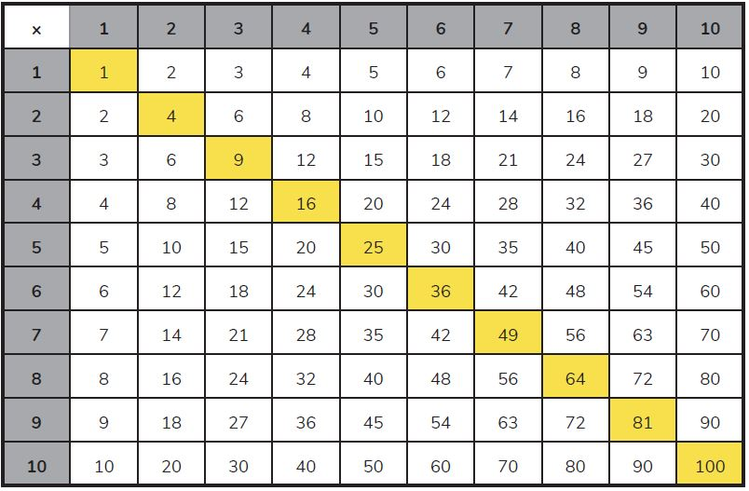  
   Print this out on the screen (with or without the yellow bits 😊 )